**Variables**

We can create variables with var and let, var is not recommended.

Always try to use let, don’t use var, try to omit it

There is also a third method to declare a variable, const

But use const only to those values which will remain constant, const declared variables can’t be rechanged once initialized.

we can declare variables like

let name;

We can initialize

name=”Amrit poudel”;

or

we can do both

let name = “Amrit poudel”;

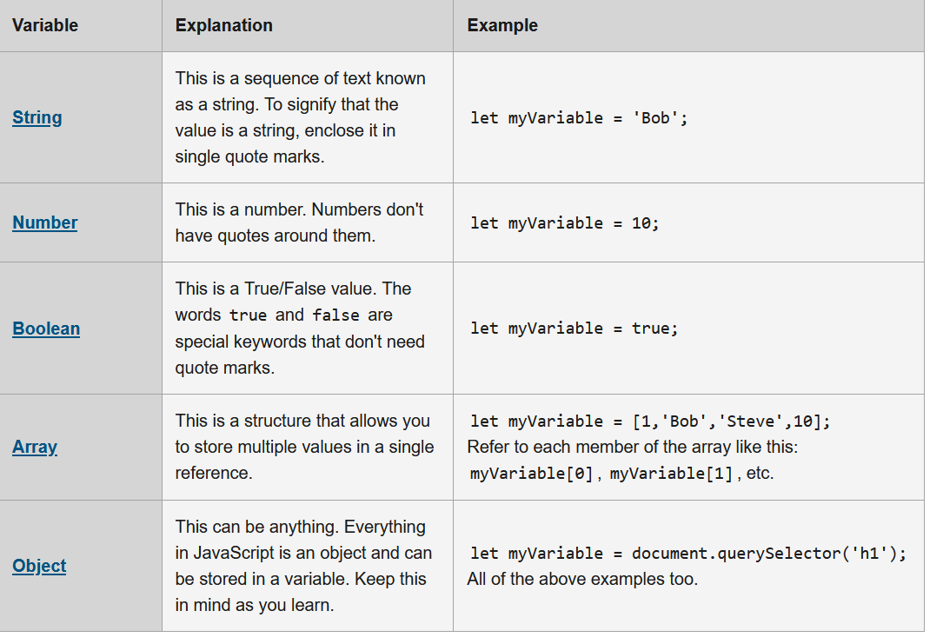

In java script variable may hold, different data types

variables : We use them so that any change we make will applies effectively to the program

Conditional statements: if-else, switch

We use them to do task based on various conditions

Functions : We use them for code reusuability

Events : Each and every interaction that occurs on webpage are events and there event handles associated with them

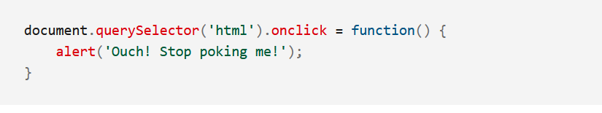

Comparision Operators in Java script

IN javascript we have two comparision operators

=== and ==

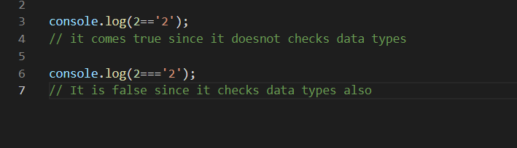

Unlike in C++ here in Javascript we can make switch statement like this also, involving strings

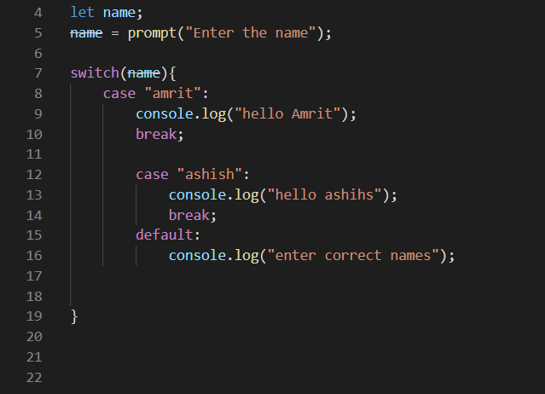

**continue;**  statement we can skip any desired step inside the loop

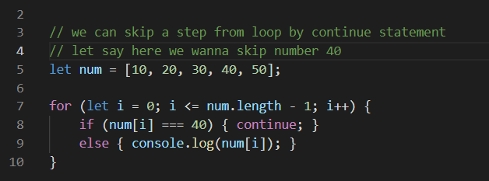

Functions in JavaScript

JS being **first class function** language the functions can be treated like variables, we can store functions in a variable names, and there are many more flexibilities with function in JS, like that

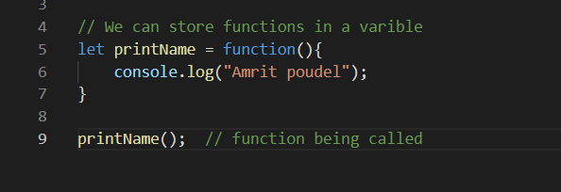

We can also define same function as

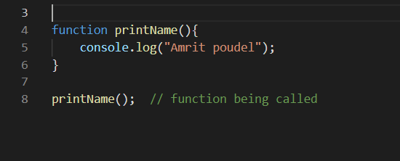

**default arguement**

We can have default argument in the functions also, in case user doesn’t send any arguments to the function the default argument gets executed

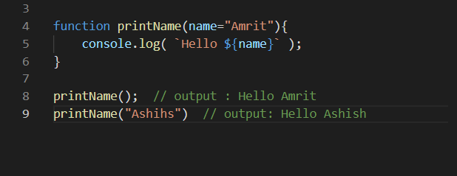

Annonymous Function

Function having no any name, it is often seen with eventListerner

But with the arrow function it is not widely used

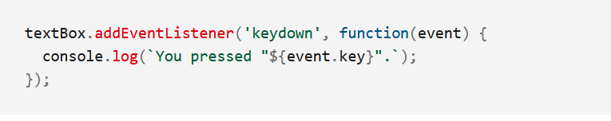

Arrow Function

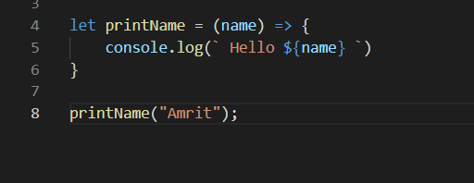

**Intro to global object in java script**

Ever wonder why, are we able to call certain methods like alert() and prompt() like this, I mean they are methods to certain object, then why we do not mention object name ?

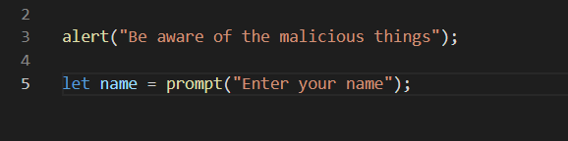

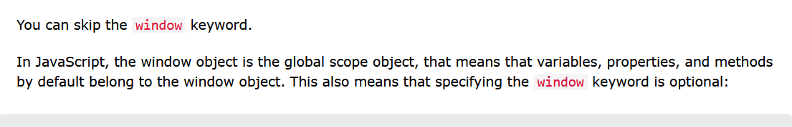

Doing above is same as

